Exploring the Features of Leading AI Platforms
A Comparative Look at Claude, ChatGPT, DeepSeek, and Google AI Studio
Course: Tools & Techniques in Data Science
Submitted by: Ahsan Tariq Wattoo
Roll no: F24BDOCS1M01061
Instructor: Mr. Omer Nazeer
Date: 16/09/2026

Table of Contents
Introduction 3
1. Claude (by Anthropic) 3
1.1 Artifacts 3
1.2 MCP (Model Context Protocol) 4
1.3 Projects 4
1.4 Claude Code 5
1.5 Extended Thinking 5
1.6 Skills 5
2. ChatGPT (by OpenAI) 5
2.1 Search 6
2.2 Canvas 6
2.3 Custom GPTs and the GPT Store 6
2.4 Memory 6
2.5 Deep Research 7
3. DeepSeek 7
3.1 Open-Weight Models (V4,Pro and V4,Flash) 7
3.2 Very Low-Cost API Access 7
3.3 DeepSeek,OCR 7
3.4 Reasoning ('Thinking') Mode 7
4. Google AI Studio (Gemini) 8
4.1 Build Mode ("Vibe Coding") 8
4.2 Free, No-Setup Development Environment 8
4.3 Native Multimodal Input 8
4.4 Grounding with Google Search and Maps 9
Conclusion 9

Introduction
Artificial intelligence platforms have moved far beyond being simple chatbots that answer questions. Today, each major platform is building its own ecosystem of tools that let users write, code, research, and even build full applications directly through conversation. This report explores four of the most widely used AI platforms available today,Claude by Anthropic, ChatGPT by OpenAI, DeepSeek, and Google AI Studio (built on the Gemini model family),and looks closely at the standout features each one offers on its own website or app. The goal is not just to list what these platforms can do, but to understand what makes each one different from the others, and where each one genuinely shines.

1. Claude (by Anthropic)
Claude is Anthropic's AI assistant, available at claude.ai. It has built a strong reputation for careful reasoning, long,document handling, and,most notably,for turning itself from a simple chatbot into a genuine workspace where things can actually be built and connected to other tools. Below are the features that make Claude stand out.

1.1 Artifacts
Artifacts is one of Claude's signature features. Instead of only replying with plain text, Claude can open a separate side panel where it writes and displays actual working content,a piece of code, a formatted document, a diagram, a webpage, or even a small interactive app or game. The person can see the result rendered live next to the conversation, ask Claude to change a specific part of it, and watch it update instantly. Anthropic reports that users have created hundreds of millions of these Artifacts since the feature launched, ranging from simple productivity tools to small educational games. Artifacts can also be published with a shareable link, so someone without a Claude account can open and use what was built.
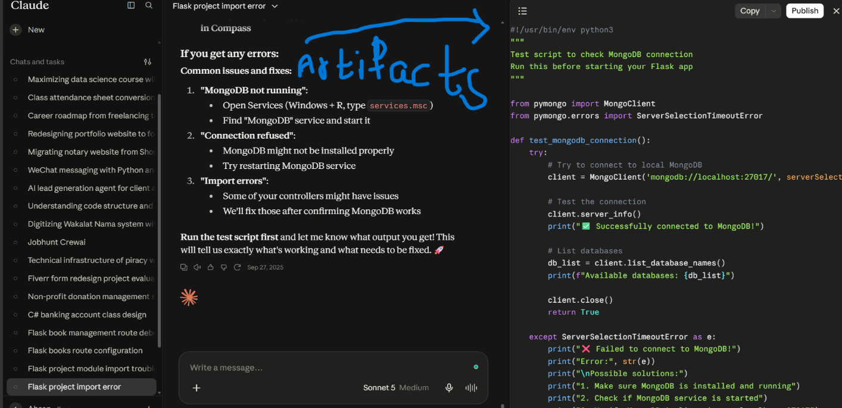
Figure 1.1-Claude Artifacts

1.2 MCP (Model Context Protocol)
MCP is an open standard created by Anthropic that lets Claude connect to outside tools and real data sources, things like Google Drive, GitHub, Slack, Notion, and calendars, instead of only working with whatever the user types into the chat box. Through MCP, Claude can read a file from Google Drive, check a GitHub pull request, or pull live information from a connected service, all inside one conversation. This is what turns Claude from a standalone chatbot into something closer to a hub that can act across the tools a person already uses.

1.3 Projects
Projects let a user group related conversations together and attach their own files or instructions once, instead of repeating context in every new chat. For example, a student could create a Project for a specific course, upload the syllabus and past notes into it, and every new conversation inside that Project would automatically have access to that material.
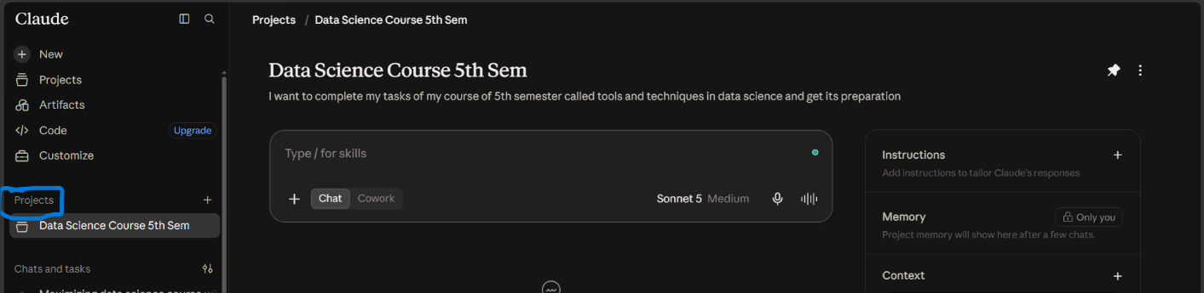
Figure 1.2-Claude Projects

1.4 Claude Code
Claude Code is Anthropic's agentic coding tool. It can read through an entire codebase, write and edit files, run terminal commands, and even commit changes to version control on its own, based on instructions given in plain language. It is aimed at developers who want to delegate real coding tasks rather than just asking for code snippets.

1.5 Extended Thinking
For harder questions,such as multi,step logic, math, or detailed planning,Claude can use an 'extended thinking' mode where it visibly works through the problem step by step before giving its final answer, similar to how a person might reason on paper before speaking. This tends to make answers to difficult questions noticeably more reliable.

1.6 Skills
In Claude, “skills” are folders of instructions, scripts, and resources that Claude loads dynamically to perform specialized tasks more accurately and consistently. They act like reusable workflows—covering things such as branded document creation, data analysis procedures, or company-specific processes—available across Claude.ai, Claude Code, and the API.

2. ChatGPT (by OpenAI)
ChatGPT, available at chatgpt.com, is arguably the most well,known AI assistant and has the broadest set of everyday features of the four platforms covered here. OpenAI has steadily added tools that turn it from a single,purpose chatbot into what feels like a full productivity suite.

2.1 Search
ChatGPT can browse the live web to answer questions, meaning it is not limited to only what it learned during training. This is especially useful for anything time,sensitive,current events, prices, recent releases,where an answer needs to reflect what is true today, not just what was true when the model was trained.

2.2 Canvas
Canvas is a side,by,side editing workspace, similar in spirit to Claude's Artifacts. It opens writing or code in its own panel next to the conversation, so long documents or programs can be edited in place,highlighting a section and asking for a specific change,rather than regenerating the whole response from scratch every time.

2.3 Custom GPTs and the GPT Store
Custom GPTs let anyone build a specialized version of ChatGPT,with its own instructions, personality, and sometimes its own uploaded knowledge,and reuse it or share it with others. The GPT Store is the marketplace where people can browse and use GPTs that others have already built, ranging from writing assistants to subject,specific tutors.
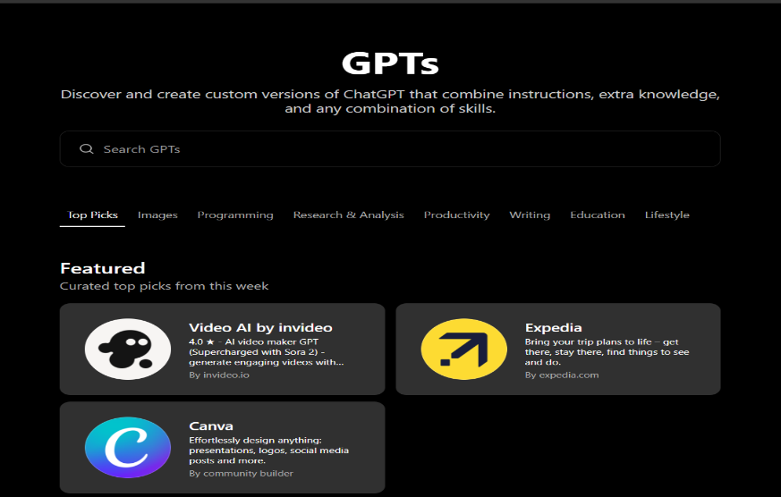
Figure 2.1-Chatgpt GPTs

2.4 Memory
ChatGPT can remember specific facts about a user across separate conversations, for example, their preferences or ongoing projects, so it does not need to be reminded every time. Users can view exactly what has been remembered and edit or delete any of it from the settings.

2.5 Deep Research
Deep Research is a research agent built into ChatGPT that can independently browse multiple sources, gather information, and compile it into a structured, cited report on a topic, rather than answering from a single pass of reasoning.

3. DeepSeek
DeepSeek is different from the other three platforms in one major way: its models are released as open-weight software rather than being locked behind a single company's app. This has made it especially popular among developers who want a low-cost or even self-hosted alternative to the bigger, more expensive platforms.

3.1 Open-Weight Models (V4,Pro and V4,Flash)
DeepSeek's current model family is released under the MIT license, meaning the model weights themselves can be downloaded and run by anyone, not just accessed through DeepSeek's own app. V4 Pro is built for the heaviest reasoning and coding tasks, while V4 Flash is a lighter, much cheaper version that still covers most everyday use cases like writing, translation, and summarizing.

3.2 Very Low-Cost API Access
DeepSeek's models are built on an efficient architecture that activates only a small portion of the full model for any given request. This keeps running costs unusually low compared to competitors, which is one of the main reasons DeepSeek gained global attention; it offers performance in the same range as much more expensive platforms at a fraction of the price.

3.3 DeepSeek,OCR
DeepSeek also offers a specialized model focused on optical character recognition, reading and extracting text from scanned documents or images with high accuracy and strong compression, which is a more specialized capability than what the general chat-focused platforms offer out of the box.

3.4 Reasoning ('Thinking') Mode
Like Claude and ChatGPT, DeepSeek offers a mode where it reasons step-by-step through harder logic, coding, or math problems before producing a final answer, rather than answering in a single quick response.

4. Google AI Studio (Gemini)
Google AI Studio, available at aistudio.google.com, is Google's free, web-based environment for working directly with its Gemini models. Unlike the other three platforms, it is aimed more at building and experimenting than at everyday conversational chatting, and its biggest advantage is that its most powerful feature is free to use.

4.1 Build Mode ("Vibe Coding")
Build mode lets a person describe an app in plain, everyday language, and Google AI Studio generates a real, working application from that description, including full front-end and back-end code. The generated code can be opened and edited directly, and the tool tracks manual edits so it can keep improving the app around changes the user makes by hand. It now supports building web apps as well as native Android apps that can be tested directly on a phone.
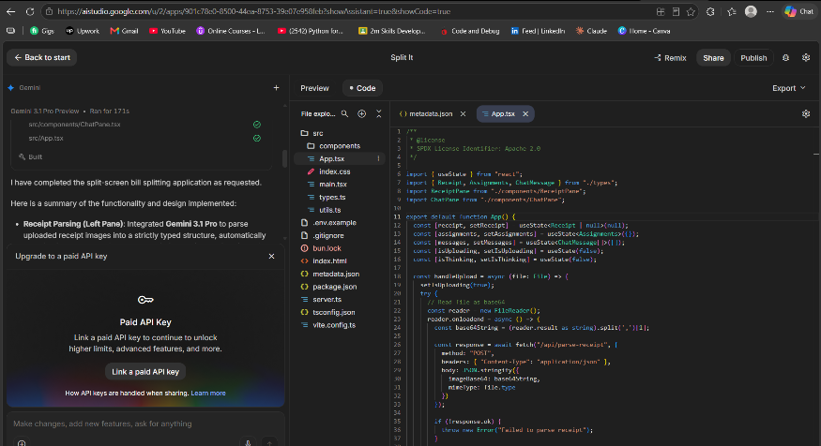
Figure 4.1-Gemini Generated Code

4.2 Free, No-Setup Development Environment
Google AI Studio allows anyone to test prompts, adjust system instructions, and call the Gemini API directly in the browser without installing anything or paying, a level of free access to a frontier-level model that none of the other three platforms fully match.

4.3 Native Multimodal Input
Gemini models in AI Studio can accept text, images, audio, and video all within a single conversation, which makes it well suited to tasks that mix different types of media at once, such as analyzing a video alongside written notes.

4.4 Grounding with Google Search and Maps
Responses can be automatically backed by real-time Google Search results or Google Maps data, which is a natural advantage for Google given how deeply these services are already built into its ecosystem.

Conclusion
Looking at all four platforms side by side, a clear pattern emerges: each one has built its standout features around a different priority. Claude focuses on connecting to outside tools and producing real, working outputs through Artifacts and MCP. ChatGPT focuses on breadth, covering search, memory, research, and collaborative editing all in one place. DeepSeek focuses on being open and inexpensive rather than feature-heavy. Google AI Studio focuses on being a free, developer-friendly sandbox tightly woven into Google's existing ecosystem. Understanding these differences makes it much easier to choose the right platform for a specific task, rather than assuming that one AI platform is simply 'better' than the others in every situation.

